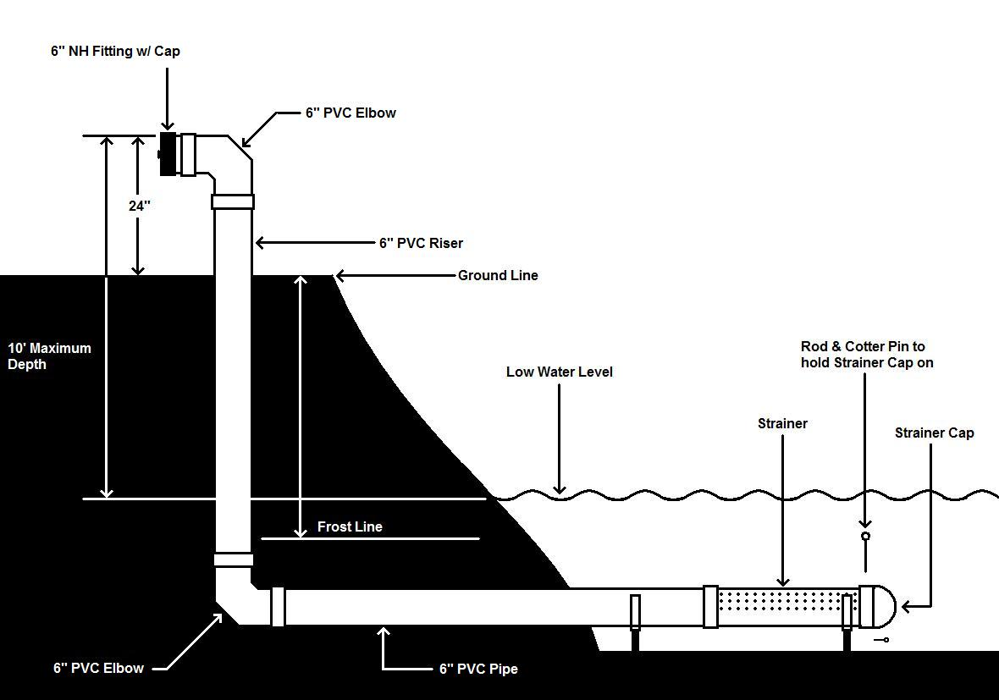

Dry Hydrant Construction

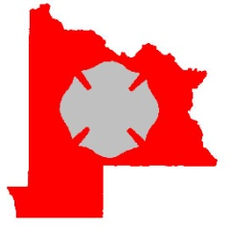
Gunnison County Fire Protection District
PO Box 1515
Gunnison, CO 81230

WHAT IS A DRY HYDRANT?

A Dry Hydrant is a “non-pressurized water delivery system” which when properly installed, will provide a ready source of water for fire department use. It is a pipe extending into a suitable body of water, with elbows, an intake and fitting on the end, which will match Gunnison County Fire Protection District suction hose. Dry hydrants are usually made from 6” or 8” pipe, we specify that dry hydrants in the District be made of 6” schedule 80 PVC pipe. There should be holes in the part of the PVC pipe that extends into the lake, stream or pond. To avoid freezing, the intake should be placed as far below the low water line as possible without being close enough to the bottom to pull debris into the pipe.

PERMITS

Contact Gunnison County Public works to obtain the necessary permits before beginning any project. Consideration also needs to be given to water rights as to how much water may be taken from that hydrant at any given time for fire suppression.

PLANNING & DESIGN CONSIDERATIONS

- Locate and map potential sites. Consider population and property loss potential. Site selection and design assistance may be available through Gunnison County Fire Protection District and/or Gunnison County Public Works.

- Check the water depth at the site during the lowest water levels of the year. A minimum of 4 feet of water over the intake screen is necessary to reduce the chance of water swirl while drafting and to prevent freezing of the intake screen.

- Check the composition of the bottom of the lake, stream or pond. Sand, gravel or rock bottom work best. Muck and vegetative matter may clog the suction screen.

- Check the ease of digging. Can a backhoe get close enough to the water to dig down at least 5 feet below the surface of the water? If a backhoe is not able to approach to dig the hole, a fire engine will not be stable enough to fill in the same place.

- Be sure that you are the landowner at the site location.

- Consider how the hydrant connection will be protected from damage or burial by snow:

- Is a crash barrier needed?
- Is the hydrant going to be available all year, or seasonally?
- How is the hydrant marked to avoid being hit by a snowplow?
- Who is responsible to keep the hydrant location open in the winter?

- Check for any buried utilities (gas lines, telephone, electrical, etc.). Call the Utility Notification Center of Colorado, dial 811 at least 72 hours before you plan to excavate. It is your responsibility to have all utility owners notified before you start excavation.

DRY HYDRANT DESIGN

A typical dry hydrant design is shown on the front cover. There is also an alternate design shown as Appendix B.

ROAD ACCESS

A fire apparatus must be able to access the dry hydrant and then turn around to return to the fire scene. The road or pull out must be able to withstand a load of 50,000 pounds and be at least 50 feet in length to accommodate a full water tanker. The turnaround does not necessarily need to be in the immediate vicinity of the dry hydrant, but the nearer it is to the hydrant, the faster the tanker will be able to get water back to the fire scene.

MAINTENANCE

Dry hydrants require periodic checking, testing and maintenance. Test the hydrants annually with a pump. After back flushing, test the flow rate to verify proper condition and to see if the line and strainer are clear of silt and aquatic growth. Streams and ponds may need frequent removal of debris, dredging or excavation of silt and protection from erosion. A record of inspection should be maintained for each hydrant.

Appendix A

Construction Notes:

- Obtain necessary permits.

- The excavator must notify utilities 72 hours prior to excavation by calling the Utility Notification Center of Colorado, dial 811.

- PVC material shall have a cell classification of 12454-B according to ASTM D-1784.

- PVC pipe shall be Schedule 80 according to ASTM D-1785.

- PVC pipe fittings shall be according to ASTM D-2466.

- Solvents for solvent cemented joints on PVC pipe shall conform to ASTM D-2564.

- All hose connections should be threaded to 6” NH (National Fire Hose) to match Gunnison County Fire Protection District suction hose.

- The intake strainer can be a well screen with a minimum area of 113 square inches of opening or 1026 3/8” diameter holes drilled into a length of PVC pipe. A flap should be provided at the end of the intake strainer to allow debris to be back flushed from the pipe, but should draw closed during suction operations.

- To prevent frost damage, mound the upland intake pipe area to maintain a minimum of 5 feet of soil cover.

- To prevent fire damage, install a 4 foot diameter gravel base at the upland pipe intake.

Appendix B

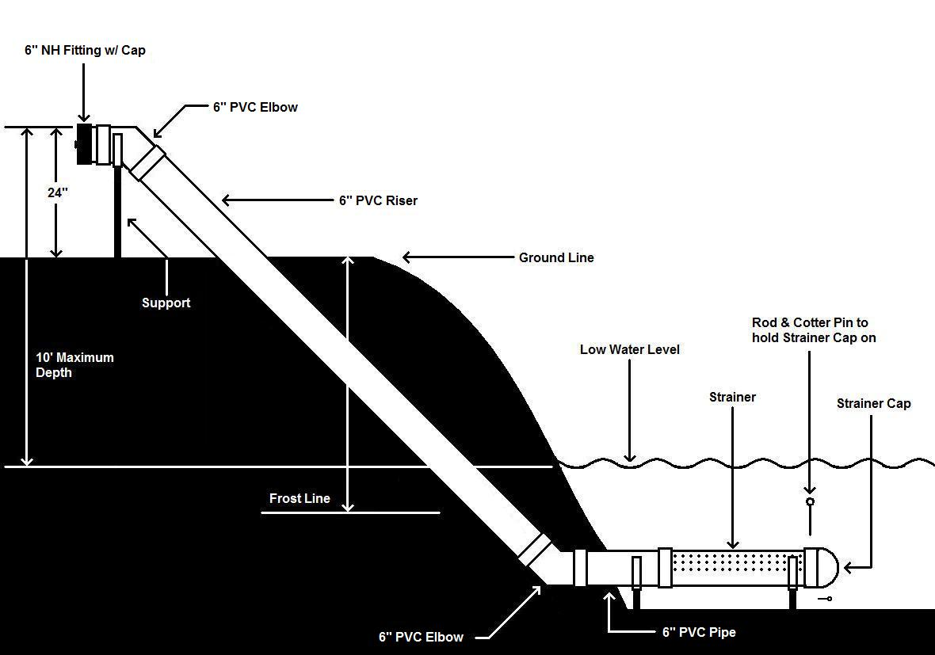

This is the alternate design for a dry hydrant. This design is preferred as it provides less friction loss when drafting. The support needs to be substantial as a large amount of weight is placed on the end of the dry hydrant when drafting.

Appendix C
Above Frost Line Dry Hydrant Installation
If the water source is not deep enough to allow installation below frost line, this precaution may be taken to help prevent freezing and breaking of the pipe by evacuation of the water with low pressure air.
Materials:
Threaded compounded gauge
Threaded air chuck
Teflon tape

Installation:
- Use portable drill to drill appropriate hole in hydrant head.
- Use tap of appropriate size and thread to thread the holes.
- Teflon tape the air chuck and compound gauge and screw into the hydrant head.
- Use portable compressor or air tank to charge the dry hydrant with air. Charge until air bubbles out or strainer. Only 5 to 10 psi are needed.
- Check the compound gauge whenever you drive by, pressure should hold through the winter.
- The compound gauge gives the advantage of showing the vacuum that you are drawing when drafting from the hydrant and detecting air leaks.
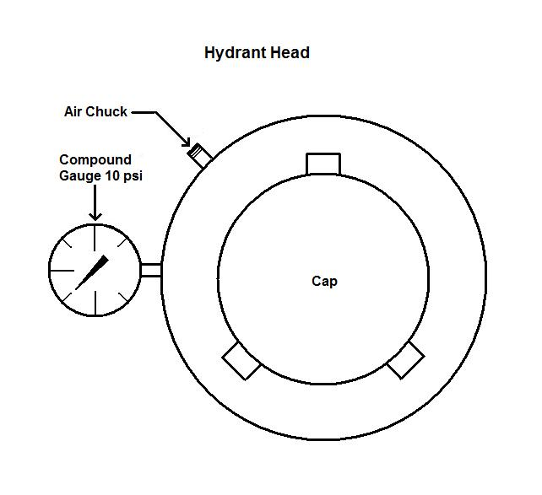
Obviously:
- There can be no air leaks in the system or the air will leak out.
- The cap must be tight.
- Caution should be taken when taking the cap off when under pressure (although 5 to 10 psi should not be dangerous).
Appendix D

Record of Inspection

- Depth of water – approximate level from surface to strainer

- Back Flush

- Gallons per minute flow

- Weed control

- Identification sign

- Protection Guards

- Paint: If the exposed portion of the dry hydrant is painted

- Road access condition

- Remarks – general comments
- Check end cap condition
- Identify equipment used for inspection
- Show the time required to prime and begin draft
- Identify provisions for the protection of the underwater portion and the exposed portion of the dry hydrant
- Record the condition of the water – muddy, scum, debris, etc.
- State whether erosion is occurring

Appendix E

Contacts:

Gunnison County Fire Protection District – (970) 641-8157

Gunnison County Public Works – (970) 641-0044

Utility Notification Center of Colorado – 811 or (800) 922-1987

